DECLARATION

I, SHAMEEMATH VT, a bonafide student of third semester MBA, the Institute of
Technology Mayyil, do hereby declare that the organizational study report entitled "
AN ORGANISATIONAL STUDY ON MARUTI SUZUKI ARENA (POPULAR VEHICLES& SERVICES) PALLIKKUNNU, KANNUR" has been prepared by me under guidance of Dr.DIVYA SUDHAKAR Assistant Professor, Institute of Technology Mayyil submitted in partial fulfillment of the requirements for the award of the degree in Master of Business Administration under Kannur University.
1 declare that this report has not been submitted by me in full or in partial to any other University or Institute at any time for the award of any degree or diploma.

PLACE: SHAMEEMATH VT
DATE: REG NO: C5GMBA2552

ACKNOWLEDGEMENT

This work couldn't be completed without the help and emotional support of several people. I am hereby thanking all of them. First and foremost, I thank Almighty God, the source of life and knowledge. I sincerely express my deep gratitude toProf. Dr.PV.JOSEPH The Principal of the Institute of Technology Mayyil, for his support and approval of this report. I am thanking Dr. DIVYA SUDHAKAR , Assistant professor of Institute of Technology Mayyil, for her timely suggestions and constant encouragement that led to the accomplishment of the study. I would like to take this opportunity to thank Mr. NAVEEN MANOHAR, HR manager, for providing me with an opportunity to do the project at Popular Maruti Suzuki Arena,Pallikkunnu, Kannur. Last but not least, I would like to thank my friends and family members for their support and guidance throughout the course of this study.

PLACE: SHAMEEMATH VT
DATE: REG NO:C5GMBA2552

TABLE OF CONTENTS

CHAPTER | CONTENT | PAGE NO.
1 | INTRODUCTION | 1-4
2 | PROFILE OF THE INDUSTRY | 5-16
3 | PROFILE OF THE COMPANY | 17-51
4 | ANALYSIS AND INTERPRETATION | 52-56
5 | FINDINGS, RECOMMENDATIONS  AND CONCLUSION | 57-58
 | BIBLIOGRAPHY

LIST OF CHARTS& FIGURES

SI NO | NAME OF CHART | PAGE NO
2.8 | SALES VOLUME OF 2024-25 | 16
3.8 | ORGANISATION STRUCTURE | 27
3.8.1 | HIERARCHY OF FINANCE AND  HUMAN RESOURCE DEPARTMENT | 28
3.9.1.2 | STRUCTURE OF SALES  DEPARTMENT | 32
3.9.2.3 | STRUCTURE OF FINANCE  DEPARTMENT | 34
3.9.3.2 | STRUCTURE OF HUMAN RESOURCE  DEPARTMENT | 36
3.9.4.1 | STRUCTURE OF ADMINISTRATION &  CORPORATE RELATIONS  DEPARTMENT | 37
3.9.5.1 | STRUCTURE OF ALLOTMENT  DEPARTMENT | 39
3.9.6.1 | STRUCTURE OF ACCESSORIES  DEPARTMENT | 40
3.9.7.2 | STRUCTURE OF QUALITY CARE  DEPARTMENT | 42
3.9.8.2 | STRUCTURE OF LEARNING & DEVELOPMENT DEPARTMENT | 44
3.10.1 | EPIC NEW SWIFT | 45
3.10.2 | WAGON R | 46
3.10.3 | BREZZA | 47
3.10.4 | CELERIO | 48
3.10.5 | ALTO K 10 | 49
3.10.6 | S-PRESSO | 50
3.10.7 | ERTIGA | 51
3.10.8 | VICTORIS

EXECUTIVE SUMMARY
This report provides an introduction to automobile industry, their function, activities etc. It also aims to understand different activities carried out in different departments of an organisation. It provides a brief insight into the working of different departments like finance,HR, sales and others.
The study was conducted at Popular Maruti Arena, Pallikkunnu, Kannur. This study takes 21 days. Here the data is collected through Primary and Secondary data. The primary data is collected through observation and discussion with managers and employees of the various departments of the organisation. The secondary data is collected through various sources which include websites and other related research work. And it also gives an analysis of the company’s strengths, weaknesses, opportunities and threats through SWOT analysis.
The main objective of the study is to familiarize with organisation structure and its functioning. On the basis of the study, findings are made and suitable recommendations are put forward to the company.

CHAPTER 1
INTRODUCTION

1.1. INTRODUCTION
An organization is a body built for a collection of individuals who join together to achieve some common goals and objectives. Organizations are often referred to as a company, institution, association etc. It typically has defined roles, hierarchies, and systems to achieve its objectives efficiently.
An organizational study involves analyzing various aspects of an organization, such as its structure, processes, culture, and performance to gain insights into how it operates and how it can improve. The data may be gathered through interviews, research, and observation. Organizational study is essential to an MBA student as it helps them to connect theory with practice.
Popular, an initiative of the prestigious Kuttukkaran Group, has been associated with quality in the automotive industry since its founding in the early years. It started off small in Kerala, India, and has developed into a powerful force in the market. Popular has continuously adjusted to shifting market trends and technology breakthroughs by maintaining a constant focus on customer satisfaction and a dedication to innovation. It now proudly maintains its reputation as a reliable brand, providing premium cars and exceptional service at multiple locations. Year after year, Popular maintains its leadership in the automobile industry by establishing new benchmarks for reliability as well as quality in every aspect of its business operations.
Founded in 1981, Maruti Suzuki Ltd embarked on a journey that would redefine India's automotive landscape. Established as a joint venture between the Indian government and Suzuki Motor Corporation of Japan, it aimed to revolutionize the country's car manufacturing sector. The iconic Maruti 800, launched in 1983, marked the beginning of a new era in Indian mobility, setting benchmarks for efficiency, affordability, and reliability. Since then, Maruti Suzuki has continually innovated, introducing a diverse range of vehicles that have become synonymous with quality and trust. With each passing year, its commitment to excellence has strengthened, making it a cornerstone of the nation's automotive industry.
This report is based on my experience in Popular Maruti Suzuki Arena, Pallikkunnu , a leading sales center in Kerala.

1.2 SCOPE OF THE STUDY
Organization study at Popular Maruti ArenaPallikkunnuis to learn about the tasks carried out in the organization. The purpose of the study was to understand the interconnection of several departments and their structure, function, and procedures.

1.3 OBJECTIVE OF THE STUDY
The organization study was carried out to achieve the following objectives:
- To familiarize with the organization structure and functioning.
- To familiarize with the different departments and their functions.
- To study overall performance of the organization.

1.4RESEARCH METHODOLOGY
A research methodology describes the techniques and procedures used to identify and analyze information regarding a specific research topic. It refers to information or facts however it also includes descriptive facts, non-numerical information, quantitative and qualitative information. The following methodologies were adopted for the study.

SOURCES OF DATA
The data required for the study is collected from both primary data and secondary data.

• Primary data
Data collected from primary sources is called primary data. In this study primary data is collected through observation and discussion with managers of the various departments of the organization.

• Secondary data
Secondary data refers to the information of facts which are already available. The background of the present study was collected from various sources which include journals, website and other related research work.

1.5 LIMITATION OF THE STUDY
- An in- depth study of the company could not be carried out due to shortage of time.
- There were difficulties in obtaining data from executives and managers due to their busy schedule.
- The company has the limitation to disclose their relevant data like financial details, so a detailed study of those is not possible.

1.6 PERIOD OF THE STUDY
The organization study at Popular Maruti Suzuki Arena, Pallikunnu is conducted for a period of 21 days that is from 02-05-2024 to 25-05-2024.

1.7 CHAPTER SCHEME
The organization study report of Popular Maruti Arena,Pallikkunnu is divided into mainly 5 chapters which includes :

Chapter1 : Introduction
This chapter includes a small introduction about organization study and Popular Maruti Arena, Scope of the study, Objectives of the study, Research methodology, Period of the study, Chapter scheme and limitations of the study.

Chapter 2: Profile of the industry
This chapter deals with profile of overall automobile industry. It includes the history of automobile industry, auto mobile industry in India.

Chapter 3: Profile of the company
It is the chapter which includes the overall profile of Popular Maruti Arena. It includes Introduction about the organization, Organization structure, Product profile, History of the organization, Different departments in an organization etc.

Chapter 4: Data Analysis and Interpretation
In this chapter the strength, weakness, opportunities and threats of the organization are analyzed through SWOT analysis.
Chapter 5: Findings, Recommendations and Conclusion
This chapter include the findings, recommendations and conclusion based on the study.

CHAPTER – 2
PROFILE OF THE INDUSTRY

2.1 INTRODUCTION
The automobile industry is all about making better cars and finding new ways for people to get around. It focuses on improving vehicles while also keeping an eye on the environment and following rules about things like emissions. Beyond just making cars, the industry looks at how people travel and explores options like ride-sharing. With technology, cars are getting safer and more connected, making driving easier for everyone. So, whether it's building cleaner cars or thinking of new ways to move, the automobile industry is always changing to fit our needs.
In this fast-paced world, the automobile industry is like the engine driving us forward. It's not just about cars; it's about making transportation better for everyone. By following rules, embracing new ideas, and using technology, the industry keeps us moving towards a future that's safer, cleaner, and more convenient for all.
The automobile was first invented and perfected in Germany and France in the late 1800s, though Americans quickly came to dominate the automotive industry in the first half of the twentieth century. Henry Ford innovated mass-production techniques that became standard, and Ford, General Motors and Chrysler emerged as the “Big Three” auto companies by the 1920s. Manufacturers channelised their resources to the military during World War II, and afterward automobile production in Europe and Japan soared to meet growing demand. Once vital to the expansion of American urban centres, the industry had become a shared global enterprise with the rise of Japan as the leading automaker by 1980.

2.2 AUTOMOBILE INDUSTRY IN INDIA
The automobile industry, along with the auto components industry, is one of the core industries in India. A well-developed transportation system plays a key role in the development of an economy, and India is no exception to it.
Automobile is one of the largest industries in the global market. Owing to its strong forward and backward linkages with several key segments of the economy.
Automobile Sector occupies a prominent place in the fabric of Indian Economy. Automobile sector is leader in product and process technologies in the manufacturing sector.
The automobile industry in the country is one of the key sectors of the economy in terms of the employment opportunities that it offers. From the singsong rhythm of the bullock cart to the jet-age, India has also travelled a long way. An average Indian’s dream car may not be the design-savvy Honda or the stately limousine, but he sure can dream, and afford, the Maruti now.

It was in 1898 that the first motorcar rode down India’s roads. From then till the First World War, about 4,000 cars were directly imported to India from foreign manufacturers. The growing demand for these cars established the inherent requirements of the Indian market that these merchants were quick to pounce upon.
The Hindustan Motors (HM) was set up in 1942 and in 1944 Premier Automobile (PAL) was established to manufacture automobiles in India. However, it was PAL who produced the first car in India in 1946, as HM concentrated on auto components and could produce their first car only in 1949.

It was left to another company, Mahindra and Mahindra (M&M) to manufacture sturdier utility vehicles, namely the American Jeep. In the 50s, the Government of India granted approval to only 7 car dealers to operate in India - HM, API, ALL, SMPIL, PAL, M&M and Telco.

The protectionist policies continued to remain in place. The 60s witnessed the establishment of the two-three-wheeler industry in India and in the 70s, things remained much the same.
Since the 80s, the Indian car Industry has seen a major resurgence with the opening up of Indian shores to foreign manufacturers and collaborators.
The 90s have become the melting point for the car industry in India. The consumer is king. He is being constantly wooed by both the Indian and foreign manufacturers.
Though sales had taken a dip in the first few months of 1999, it is back to boom time.

New models like Maruti’s Classic, Alto, Station Wagon, Ford’s Ikon, the new look Mitsubishi Lancer are all being launched with an eye on the emerging market. In these last years of the millennium, suffice it is to say that Indian cars will only grow from strength to strength.
The automobiles sector is divided into four segments - two-wheelers, passenger vehicles, commercial vehicles, three wheelers & two wheelers.
India is one of the world’s fastest growing passenger car markets it is second largest two wheeler manufacturer and fifth largest commercial vehicle manufacturer. It is also home for the largest motor cycle manufacturer.
Moreover, India is fourth largest passenger car market in Asia.

2.3 TOP AUTOMOBILE BRANDS IN INDIA

- MARUTI SUZUKI (Market Share: 41.6 %)
Founded on 24 February 1981, Maruti Suzuki was India's first automobile manufacturer. Maruti Suzuki has become one of the largest automobile manufacturers in the country due to its low cost and affordability. Operating costs are lower than its competitors. Powered by a 970cc engine, the Maruti Suzuki 1000 was the first car launched by the company after it was established in Gurugram, Haryana. It has become India's best-selling automobile company.
The range is 294,000 to 1.151 million.

- HYUNDAI MOTORS (Market Share: 14.9 %)

Named Hyundai Motor India in 1996, it is the company with the largest shareholding after Maruti Suzuki. The range of changes provides a nuanced insight into how customers across all customer groups benefit from it. The company has a fleet of 991,000 to 6.5 million vehicles.

- MAHINDRA & MAHINDRA (Market Share: 11.4%)
Founded in 1945, Mahindra & Mahindra (M&M) has established itself as one of India's leading automotive manufacturers, known for its diverse range of vehicles, including SUVs, commercial vehicles, and electric vehicles. As of recent years, Mahindra is one of the major players in the Indian automotive market, holding a significant market share, second only to Maruti Suzuki.

• TOYOTA MOTOR CORPORATION (Market Share: 6.1%)
Toyota Motor Corporation, established in 1937, is a leading global automotive manufacturer known for its innovative engineering and commitment to quality. As one of the largest automotive companies worldwide, Toyota holds a significant market share, with a strong presence in various regions, including India through Toyota Kirloskar Motor.

- TATA MOTORS (Market Share:2.3 %)
Toyota Motor is a Japanese company founded in 1937 and headquartered in Japan. Today it is the second largest automobile manufacturer in the world. It produces and sells hybrid electric vehicles and has a worldwide reputation. Toyota engines are said to be durable, making them popular among customers.
The price of his car varies between 7.01 million rupees and 8.35 million rupees.

2.4 CAR SEGMENTS IN INDIA
- A-Segment (Mini Hatchbacks)
- A-segment cars are ideal for urban roads due to their compact dimensions. They are also easy to drive due to simple vehicle controls.
The below points divulge more details of A-Segment cars.
- The hatchbacks in this segment measure less than 4 metres in length.
- The mini hatchbacks come with a small engine that produces enough power suitable for daily commutes.
- Generally, the mini hatchbacks are available only with fuel-efficient petrol/CNG engines.
- The mini hatchbacks are easy-to-drive with options such as AMT transmission.
- A-segment cars come with only essential features. It also helps to keep the costs down.
- The segment is further classified into two: A1 (entry-level models) and A2 (compact hatchbacks).
A1: Renault Kwid, Maruti Alto and Datsun Redi-Go
A2: Maruti Wagon R, Hyundai Santro, Tata Tiago and Maruti Celerio.

- B-Segment (Small Hatchbacks)

- B-segment cars or small hatchbacks are best suited for you if your driving requirements are daily commuting and occasional long drives. They are slightly larger than A-segment vehicles and offer more stability on the road. For more details of the small car segment, refer to the points below.
- B-segment cars measure just under 4 metres in length. They are also a bit taller and wider than A-segment cars.
- The cars in this segment get mid-size engines ranging from 1-litre to 1.5 -litre, depending on the make and model.
- One also find an array of gearbox options such as manual, automatic, AMT, DCT and CVT.
- They are available in both petrol and diesel guise.
- Another highlight of these cars is that they come with premium creature comfort features.
- The B-segment is divided into B1 (small hatchbacks) and B2 (premium hatchbacks) segments.
B1: Hyundai Grand i10 Nios and Maruti Swift.
B2: Hyundai i20, Honda Jazz, Tata Altroz and Maruti Baleno.

• C-Segment (Small sedans/family cars)

- Small sedans or also called family cars, fall under the C-segment. It is further divided into two segments which we will explain in the following sections. Due to its sub-segments, there are plenty of options when it comes to C-segment cars in India.
Sub-compact sedan segment (C1-segment)
- Sub-compact sedans can be defined as an extension of B-segment cars with an added boot for more luggage space. They are compact in dimension and suitable for driving on urban roads. Below are more details of compact sedans.
- Sub-compact sedans measure just under 4 metres in length.
- Generally, they feature a similar platform as B-segment hatchbacks.
- The engine and gearbox options also remain similar to small hatchbacks.
- The compact sedans come with all the essential safety and creature comfort features.
- Maruti Dzire, Honda Amaze, Hyundai Aura and Tata Tigor are some of the compact sedans available in India.
Small sedan segment (C2-segment)
- Small sedans offer a spacious interior due to their large body proportions. Yes, they are larger than compact sedans and provide a premium driving experience. Refer to the points below for more details of the segment.
- The C2-Segment cars measure well over 4 metres in length.
- Generally, the small sedans are built on a unique platform.
- The large body proportions increase the weight of the vehicle. Hence, they are available with bigger engines ranging from 1.5-litre to 1.6-litre.
- You can choose from petrol or diesel engine variants.
- The automatic, CVT or torque-converter gearbox options make driving them easier despite the large dimensions.
- Some of the prominent small sedans in India are Honda City, Hyundai Verna, Maruti Ciaz, Skoda Slavia and Toyota Yaris.

• D-Segment (Mid-size sedans/family cars)

- D-segment cars or mid-segment cars are all about premium design and luxurious interiors. They are larger than C-Segment vehicles and also command a higher price tag. Below are more details of this segment.
- The D-segment cars are longer than their counterparts from the Csegment in terms of dimensions.
- The interior offers ample space for rear passengers and comes with all the bells and whistles for comfort and convenience.
- They get higher capacity engines running between 1.6-litre to 2-litre.
- Available in both petrol and diesel variants.
- Similar to C-Segment, the D class further bifurcates into two segments:
D1 and D2.
D1: Skoda Octavia, Hyundai Elantra, Honda Civic, etc.
D2: Honda Accord, Skoda Superb, Toyota Camry, BMW 3-Series, etc.

2.5 INDUSTRY SCENARIO

• Production
In 2024-25, India produced 259, 31,867 vehicles, including passenger vehicles, commercial vehicles, three-wheelers, two-wheelers, and quadricycles.
- Sales
Passenger vehicle sales increased from 30, 69,523 to 38, 90,114 units in 2024-25.
- Exports
Passenger vehicle exports increased from 5, 77,875 to 6, 62,891 units in 2024-25.
- Contribution to GDP
The automobile industry contributes 7.1% to India's GDP.

• Employment
The automobile industry provides direct and indirect employment to over 19 million people.
• EV market
The EV market is expected to grow at a CAGR of 49% between2022-2030.

• Government support
The Indian government is promoting sustainable and electric mobility through incentives, subsidies, and stringent emission norms.

• Partnerships
Indian automakers are collaborating with international players to enhance product quality and expand market reach.

2.6RECENT DEVELOPMENTS
In the Indian car industry, several recent developments have shaped the landscape, reflecting the industry's response to changing consumer preferences, technological advancements, and regulatory requirements. Here are some notable developments:

• RISE OF ELECTRIC VEHICLES (EVS)
The Indian car industry is witnessing a growing focus on electric vehicles (EVs) as the government pushes for a shift towards cleaner mobility. Established players like Tata Motors, Mahindra & Mahindra, and Hyundai, as well as startups like Ola Electric and Ather Energy, are launching EV models and expanding their EV portfolios.

• LAUNCH OF CONNECTED CARS
Car manufacturers in India are increasingly incorporating connected features into their vehicles, enhancing safety, convenience, and entertainment options for consumers. Models such as Maruti Epic New Swift, Hyundai Venue, MG Hector offer advanced connectivity features like remote diagnostics, navigation, and smartphone integration.

• FOCUS ON SAFETY
Safety has become a key focus area for car manufacturers in India, with increasing awareness among consumers and regulatory mandates. Companies are equipping their vehicles with features like airbags, ABS, electronic stability control (ESC), and advanced driver assistance systems (ADAS) to enhance safety standards.

• SHIFT TOWARDS SUVS AND CROSSOVERS
Indian consumers are showing a growing preference for SUVs and crossovers, leading car manufacturers to focus on expanding their SUV line-ups. Models like Hyundai Creta and Tata Harrier have gained popularity, along with Maruti Suzuki's Vitara Brezza and S-Cross, reflecting this trend.

• DIGITAL TRANSFORMATION
Car companies are embracing digitalization to enhance the car buying experience and streamline operations. Digital platforms for booking test drives, customizing vehicles, and online sales have become increasingly common, catering to the preferences of tech-savvy consumers.

2.7CHALLENGES FACED BY THE INDIAN AUTOMOBILE INDUSTRY

• SUPPLY CHAIN DISRUPTIONS
The Covid-19 pandemic has led to significant disruptions in the supply chain of the automobile industry. Many auto manufacturers have struggled with sourcing critical components, and this has led to production delays and increased costs.

• CHANGING CONSUMER PREFERENCES
There has been a shift in consumer preferences towards electric and hybrid vehicles, which is a challenge for the Indian automobile industry that has historically been focused on producing gasoline and diesel vehicles.

• INCREASING COMPETITION
The Indian automobile industry is highly competitive, with both domestic and international players vying for market share. This puts pressure on companies to innovate and improve their products and services, which can be a challenge.

• RISING INPUT COSTS
The prices of raw materials, such as steel and aluminium, have been increasing globally, which has led to higher input costs for the automobile industry. This has put pressure on companies to increase prices or absorb the costs, which can impact their profitability.

• REGULATORY CHALLENGES
The Indian automobile industry is subject to a range of regulations related to safety, emissions, and fuel efficiency. Compliance with these regulations can be challenging for manufacturers, particularly smaller companies that may lack the resources to invest in research and development.

• INFRASTRUCTURE CHALLENGES
The development of electric vehicle infrastructure, such as charging stations, is still in its early stages in India. This can be a challenge for companies that are looking to introduce electric vehicles to the market, as consumers may be hesitant to purchase these vehicles if charging infrastructure is not readily available.

• ECONOMIC SLOWDOWN
The Indian economy has been facing a slowdown in recent years, which has impacted consumer spending on automobiles. This can be a challenge for the automobile industry, as companies may struggle to maintain their sales volumes and
profitability.

AN ORGANISATIONAL STUDY ON MARUTI SUZUKI ARENA (POPULAR VEHICLES& SERVICES) PALLIKKUNNU, KANNUR

2.8 SALES VOLUME OF 2024-25
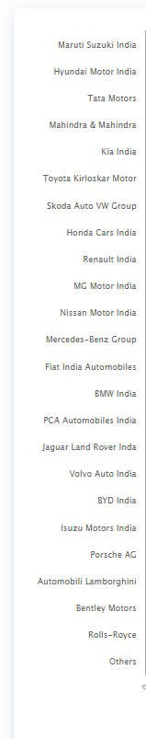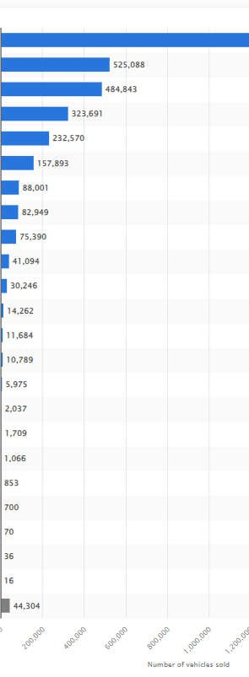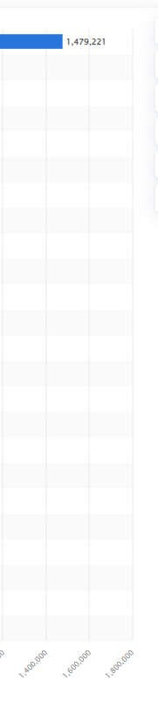

INSTITUTE OF TECHNOLOGY, MAYYI
L,KANNUR

16

CHAPTER 3
PROFILE OF THE COMPANY

3.1 INTRODUCTION
Dealerships form an intrinsic part of the automobile sector, playing the role of an intermediary between the customers and the manufacturers. The dealership plays an indispensable role in the overall vehicle supply chain, providing a local vehicle distribution channel based on a contract with an automaker. It also plays a key role in the aftermarket space by providing maintenance services and supplying spares/automotive parts and accessories.
As a cherished member of the Kuttukaran Group, Popular Vehicles and Services Ltd. is a shining example of excellence in the Indian auto dealership industry. Customers all over South India have shown Popular Dealerships the utmost respect and confidence over the course of their five-decade history. From its humble start to its present position, Popular Dealerships has never changed in its dedication to providing outstanding customer service and cultivating long-lasting connections with its customers.
Popular Vehicles & Services Limited (“Popular Vehicles & Services” or “Company”), belongs to the diversified Kuttukaran Group, operating multi-brand automobile dealerships in Kerala, Tamil Nadu and Karnataka. They are among the top six dealerships in India, in terms of sales by volume, as of March 31, 2023, with respect to each of passenger and commercial vehicles dealerships.
Founded by the late Shri. K. P. Paul, the Group launched the Company in 1984 as one among the first batch of Dealers appointed by Maruti Suzuki in India. Over the years, the operations were scaled up across Kerala and Chennai.
Popular Vehicles now operates the Fifth (Fiscal 2023) largest selling Maruti Suzuki dealership in India under the Arena network (by volume) and the Eighth (Fiscal 2023) largest selling Maruti Suzuki dealership in India under the Nexa network (by volume), as of March 31, 2023. The dealershipwere ranked number one (Fiscal 2023) in the all India dealer ranking, in terms of volume of service, for Maruti Suzuki (Arena and Nexa) in the financial year 2023.

Popular Vehicles & Services Limited (Popular) has achieved the "Royal Platinum Band" by Maruti Suzuki for Arena Dealerships in Kerala, "Gold Band" for Arena Dealerships in Chennai and "Alpha Band" for Nexa Dealerships in financial year 2022 - 2023.
A Customer Relationship Center caters to customer’s needs and queries round the clock. The Company also actively connects with its Customers through social media channels.
The Kuttukaran Group has over 70 years of experience in the automobile industry. Mr. John K. Paul is now a Whole Time Director and one of the Promoters who has over 49 years of experience in the automobile sector. He is currently the President of the Kerala Automobiles Dealers Association. Mr.Francis K Paul, Whole Time Director. Mr. Naveen Philip, is now the Managing Director and one of the Promoters who has over 26 years of experience in the automobile industry. The senior management team is also experienced in the automobile dealership industry. The dealership believe that the experience, depth and diversity of their management team and Promoters and the long standing presence of the Kuttukaran Group in the automotive industry have enabled them to become valued partners of each of their OEMs giving a distinct competitive advantage in the industry in which the company operate.
The core philosophy of the Company is “Passionately Enriching Mobility”.
Popular Vehicles and services is incorporated on 05th July 1983. It is classified as nongovernment company and is registered at Registrar of companies;The registered office of Popular Vehicles and Services Limited is at KUTTUKARAN CentreMamangalam Cochin, Ernakulam, Kerala.
As of July 31, 2023, the company operated through a network of 59 showrooms, 126 sales outlets and booking offices, 31 pre-owned vehicle showrooms and outlets, 134 authorised service centres, 40 retail outlets, and 24 warehouses located across 14 districts of Kerala, 8
districts in Karnataka, 12 districts in Tamil Nadu and 7 districts in Maharashtra. While the sales outlets and booking offices complement the sales through showrooms, the retail outlets facilitate sale and distribution of spare parts and accessories.
The last reported AGM (Annual General Meeting) of Popular Vehicles And Services Limited, per records, was held on 18 August, 2023.Directors of Popular Vehicles and services limited are Jacob Kurian, John K. Paul, Francis K. Paul, Naveen Philip and others.
The Popular Vehicles and Services has listed at BSE and NSE on 19th March 2024.
3.2 VISION
Popular will be the world’s most admired corporate by progressively delivering greater value through entrepreneurship within.
3.3 MISSION
Create memorable customer experience wish happy employees through operational excellence delivering profitable growth.

3.4 HISTORY
The Company was originally incorporated as Popular Vehicles and Services Limited on
July 5, 1983 at Kochi, Ernakulam, Kerala, India as a public limited company under the Companies Act, 1956 and received its certificate for commencement of business on July 14, 1983, issued resolution passed by the Shareholders at the EGM held on December 29, 2014 and the name of the Company was changed to Popular Vehicles and Services Private Limited. A fresh certificate of incorporation consequent upon conversion of the
Company to a private limited company was issued on March 24, 2015 by the RoC. The Company was subsequently converted into a public limited company pursuant to a special resolution passed by the Shareholders at the EGM held on June 11, 2018 and the name of the Company was changed to Popular Vehicles and Services Limited. A fresh certificate of incorporation consequent upon conversion of the Company to a public limited company was issued on July 10, 2018 by the RoC.

Major events and milestones:
- In 1984 The Company commenced automobile dealership business with setting up their first Maruti Suzuki showroom in Trivandrum, Kerala.
- 1997 The Subsidiary, PMMIL commenced its first dealership in Kerala for Tata commercial vehicles
- 2002 The Company commenced the Popular Motorsdealership in Chennai, Tamil Nadu, for Maruti Suzuki passenger vehicles
- 2005 The Subsidiary, PADL commenced spare parts distribution business in Kerala
- 2006 The Subsidiary, PMMIL commenced the Popular Motors dealership in Tamil Nadu for Tata Motors (Commercial) commercial vehicles
- 2008 The step-down Subsidiary, VMPL commenced the Vision
Motorsdealership in Kottayam, Kerala for Honda passenger vehicles
- 2015 Investment by BanyanTree in the Company
- 2021 -The Subsidiary, KGPL, entered into a dealership agreement with Piaggio Vehicles Private Limited to operate dealerships for three-wheeler electric vehicles in
Ernakulam -The Subsidiary, KCPL, entered into a letter of intent with Ather Energy Private Limited to operate the two-wheeler electric vehicles dealership in Trivandrum
- 2022 -The Subsidiary KCPL, entered into a letter of intent with Ather Energy Private Limited to operate the two-wheeler electric vehicles dealership in Nagercoil, Tamil Nadu
- 2023 -The step-down Subsidiary PMPL, entered into a slump sale agreement to acquire BharatBenz dealership business in Maharashtra -The Company received an in-Principle approval for Maruti Suzuki dealership (Arena Channel) at Bangalore, Karnataka.
- 2024 - The Company strengthened its presence in the electric vehicle segment through expansion of Ather Energy dealerships and service operations in Kerala and Tamil Nadu.
- 2025 - The Company expanded Maruti Suzuki operations across Kerala, Tamil Nadu, Maharashtra and Karnataka.

3.5 MARUTI SUZUKI DEALERSHIP
The first dealership in Kerala for Maruti Suzuki vehicles was awarded to the Company in 1984. They operate the Maruti Suzuki dealership under the “Popular” brand and sell new passenger vehicles manufactured by Maruti Suzuki through
Thenetwork of ‘Arena’ and ‘Nexa’ dealerships, in various districts of Kerala and Tamil Nadu. Also facilitate the sale of pre-owned vehicles under the ‘Maruti True Value’ brand and provide servicing and repairs for vehicles manufactured by Maruti Suzuki. The company also operate 7 driving schools under the ‘Maruti Driving School’ brand in Kerala.Pursuant to the Maruti Dealership Agreements, they have been appointed as authorised dealers of Maruti Suzuki passenger vehicles, on a non-exclusive and nontransferable basis, to sell passenger vehicle, spare parts and accessories of the passenger vehicles and provide services and repairs for the passenger vehiclesmanufactured by Maruti Suzuki in various districts of Kerala and in Chennai of Tamil Nadu. Maruti Suzuki has alsogranted a non-exclusive, non-assignable and personal right to our Company to use their name and marks for thepurpose of or in connection with the identification, advertising, promotion, sale, supply or servicing of passengervehicles of Maruti Suzuki during the agreement. The Maruti Dealership Agreements may be terminatedby Maruti Suzuki without cause by providing a notice of 90 days Further, Maruti Suzuki also has the right to terminatethe Maruti Dealership Agreements on account of breach of the terms of the agreement by the dealership or, upon the becoming bankrupt or committing fraud in connection with the agreements. Pursuant to the terms of the agreements,the dealership are required to ensure that they comply with the specified operational procedures, the technicians aretrained as per Maruti Suzuki’s requirements.

3.6 CORPORATE SOCIAL RESPONSIBILITY ACTIVITIES
The projects or programmes to be undertaken by Company as CSR in India will be considered and approved by the CSR Committee of Company. Any project or programme that is exclusively for the benefit of Company’s employees would not be considered as CSR. Company’s primary focus areas for CSR activities are:
- Eradicating hunger, poverty and malnutrition, promoting health care including preventive health care and sanitation and making available safe drinking water.
- Promoting education, including special education and employment enhancing vocation skills especially among children, women, youth, and elderly and the differently able persons and livelihood enhancement projects.
- Promoting gender equality, empowering women, setting up homes and hostels for women and orphans; setting up old age homes, day care centers and such other facilities for senior citizens and measures for reducing inequalities faced by socially and economically backward groups.
- Ensuring environmental sustainability, ecological balance, protection of flora and fauna, animal welfare, agro forestry, conversation of natural resources and maintaining quality of soil, air and water.
- Protection of national heritage, art and culture including restoration of building and sites of historical importance and works of art and setting up of public libraries.
- Measures for the benefit of armed forces veterans, war widows and their dependents.

- Training to promote rural sports, nationally recognized sports, Paralympics sports and Olympic sports.

- Contribution to the Prime Minister’s National Relief Fund or any other fund set up by the Central Government for socio-economic development and relief and welfare of the Schedules Castes, the Scheduled Tribes, other backward classes, minorities and women.
- Contributions or funds provided to technology incubators located within academic institutions which are approved by the Central Government.
- Rural Development Projects

3.5 OTHER ESTABLISHMENTS AUTOMOBILE
- POPULAR VEHICLES & SERVICES
- POPULAR MARUTI
- POPULAR NEXA
- VISION MOTORS
- POPULAR MEGA MOTORS
- ECOMARQ
- ATHER
- PIAGGIO
- MARQLAND
- PRABAL TRUCKING

EDUCATION
- KUTTUKARAN INSTITUTE
- KUTTUKARAN POLYTECHNIC COLLEGE
- BLUETIMBRE

NEW VENTURES
- MEMORYTRAIN
- REGIIS INSURANCE BROKERS

3.6 COMPANY PROFILE (IN SHORT)
Founder | K P Paul
Incorporation date | 05 July 1983
CIN | U50102KL1983PLC003741
Registration number | 3741
Parent company | Kuttukaran Group
Chairman | Jacob Kurian
Managing Director | John K Paul
Director | Naveen Philip
(Source : Company Records)

3.7BRANCH PROFILE
Company name | Maruti Suzuki Arena ( Popular Vehicles and Services )
Branch Head | Dipil Mohan
Location of the company | Pallikkunnu, Kannur
Industrial Category | Automobile
No. Of employees | 40
Working time | 9 am to 6 pm
(Source : Company Records)

3.7.1 MANAGEMENT
Branch Head | Dipil Mohan
Sales Managers | Jayesh  Rakesh p  Jiby jose
Accounts Head | Shiju
Quality Care Manager | Aneesh
Assistant HR Manager | Reshma P.V  Naveen Manohar
Administration & Corporate Sales Manager | Giridharan K.V
Accessories Manager | Vineesh
Allotment | Salna
(Source : Company Records)

3.8 ORGANISATION STRUCTURE

BRANCH HEAD
SALES MANAGERS
TEAM LEADERS
EXECUTIVES
ADMINISTRATION
& CORPORATE
SALES
EXECUTIV
E
ALLOTMENT HEAD
EXECUTIV
ES
ACCESSORIES
DEPARTMENT
QUALITY CARE
MANAGER
CUSTOMER
RELATION
EXECUTIVES
HOSTESS
HOUSE KEEPING
STAFF

3.8.1 HIERARCHY OF FINANCE AND HUMAN RESOURCE DEPARTMENT

CLUSTER
HEAD
FINANCE
HEAD
ACCOUNTANT
EXECUTIVES
HR
MANAGER
LEARNING &
DEVELOPMENT
HR
ASSISTANT

3.9 DEPARTMENTS
Popular Maruti Arena, Pallikkunnuhas7major functional departments for ensuring the smooth working of the organization. They are:
- Sales Department
- Finance Department
- Human Resource Department
- Administration & corporate Department
- Allotment Department
- Accessories Department
- Quality Care Department.
- Learning & Development Department

3.9.1 SALES DEPARTMENT
A sales department is responsible for selling products or services for a company. The department comprises a sales team that works together to make sales, increase profitability and build and maintain relationships with customers to encourage repeat purchases and brand loyalty. Further, a quality salesperson helps to identify a customer's unique needs and makes sure that those needs are met.
The department head is the senior manager, who oversees team leaders and executives, who are now referred to as relationship managers by the organization. There will be five to eight executives working for one team leader. Sales managers make sure executives are productive by assigning them a daily goal. That's two inquiries a day, totalling fifty inquiries in a month. Walk-ins at showrooms, data calling, social media, friends, and family are some of the ways to get the inquiry. The executives use the sales track app to submit their inquiry. A sales manager's primary responsibilities include to boost sales and track at least three vehicles that are producing results.

Following the punch-in inquiry, the team leader calls the clients to confirm the booking; these cases are referred to as hot prospectuses. Once the team leader gets in touch with the executive managing the finance for vehiclesthe file is then forwarded to the allocation department to undergo further registration procedures.
Promotion through advertisement is a strong way of marketing for Popular Vehicles.
The methods include notice distribution, loan mela, online promotions etc.
The main sales promotion done by the company are :
- Showroom Sales :
In this the customers walk in to the showroom to know about the details of the product. The walk- in customers are allotted to the trained sales executives who are present in the showrooms. They give detailed explanation about the products features, colours, price and various offers given by the manufacturer to the customer.

- Field sales:
The sales executives conduct some events like loan mela, notice distribution which is outside of the showroom.

3.9.1.1Objectives
- To increase sales
- Enhancing sales activities
- To increase productivity

3.9.3 Customer Relationship Management (CRM) Strategy
Relationship Building Initiatives

• Personalized Communication
Sales executives utilize personalized communication strategies to engage with customers, addressing their unique needs and preferences. This may include tailored emails, follow-up calls, and customized offers based on customer history.

• Feedback Collection
The department actively seeks customer feedback through surveys and direct communication post-purchase. This information is crucial for understanding customer satisfaction and areas for improvement.

• Loyalty Programs
Implementing loyalty programs incentivizes repeat purchases, rewarding customers for their continued business. This fosters a sense of belonging and appreciation among customers.
Technology Integration

• CRM Software Utilization
The sales team utilizes CRM software to track customer interactions, manage inquiries, and store customer data. This technology enables seamless communication and helps sales executives follow up effectively.

• Data Analysis for Customer Insights
Analysing customer data allows the sales department to identify trends, preferences, and potential opportunities for upselling or cross-selling, enhancing the overall customer experience.
Customer Engagement Strategies

• Follow-Up Processes
After sales transactions, the team ensures consistent follow-up with customers to check on their satisfaction and address any issues that may arise. This demonstrates the company’s commitment to customer care.

• Community Engagement
Engaging with customers through community events and social media platforms strengthens the brand’s presence and fosters a community around the product or service.
Performance Metrics

• Customer Retention Rates
The department monitors customer retention rates as a key performance indicator, aiming for high levels of repeat business as a sign of successful relationship management.

• Net Promoter Score (NPS)
Tracking NPS helps measure customer loyalty and the likelihood of customers recommending the company to others, providing valuable insights into overall satisfaction.

3.9.1.2 STRUCTURE OF SALES DEPARTMENT

SALES MANAGER

TEAM LEADER

EXECUTIVES

3.9.2 FINANCE DEPARTMENT
The Finance Department at a car showroom serves as the financial backbone of the operations, ensuring the seamless flow of transactions and providing invaluable support to both customers and internal teams.For smooth functioning of every organisation proper money management is essential.
The Branch Head and Finance Head play pivotal roles in steering the company towards its goals. Their combined efforts culminate in sound financial decisions and streamlined operational processes.An advance for the vehicle should be paid to purchase the vehicle within13 days,if the customer failed to pay the amount should pay an interest amount. For registration and to pay road tax, the fund should be fully paid.The department used tally till 2017; now they use Wings ERP for recording transactions.

3.9.2.1 Financial Activities
- Paying road taxes.
- Customer payments.
- Vendor payments.
- Managing day-to-day branch operations.
- Creating a monthly performance report.
- Paying and Evaluating staff-related expenses.
- Managing receivables from customers and Maruti.
- Fund generation through finance company.
- Meeting expenses of outlets.

3.9.2.2 Features of Wings ERP

• Real-Time Data Processing
Wings ERP enables real-time recording and processing of financial transactions, ensuring that data is always current and accessible for decision-making.

• Comprehensive Financial Reporting
The system provides detailed financial reports, including profit and loss statements, cash flow analyses, and balance sheets, allowing for better visibility into the company’s financial health.

• Integrated Modules
Wings ERP integrates various financial functions such as accounts payable, accounts receivable, payroll, and inventory management, facilitating seamless operations across departments.

• Automated Workflows
Automation of routine tasks, such as invoicing and payment reminders, reduces manual errors and saves time, allowing staff to focus on strategic financial activities.

• User-Friendly Interface
The intuitive design of Wings ERP makes it easier for finance personnel to navigate the system, enhancing user adoption and efficiency.

3.9.2.3 STRUCTURE OF FINANCE DEPARTMENT

FINANCE HEAD

ACCOUNTANT

EXECUTIVES

3.9.3 HUMAN RESOURCE DEPARTMENT
A Human Resource (HR) Department is a crucial component of any organization responsible for managing and overseeing various aspects related to the workforce. Its primary function is to ensure that the organization has the right people with the right skills in the right positions to achieve its objectives effectively.
Their main job is to find, hire, and take care of the people who work here. Think of them as matchmakers – they look for the right fit between job openings and the skills and personalities of potential employees.
But HR does much more than just hiring. They're also like the peacekeepers of the workplace, making sure everyone gets along and feels valued. If there are any problems or conflicts between employees, HR steps in to sort things out and make sure everyone is treated fairly.Thedepartment provides effective policies, guidelines and support.
They organize events and activities to boost morale and create a positive work environment. The HR Department also runs a rewards and recognition program to celebrate employees who do great work. This helps everyone feel appreciated and motivated. Plus, every month, they throw a birthday cake cutting for all employees born that month.
The department support and care for the people who work here, making sure that everyone can do their best work and contribute to the success of the dealership. And they do all of this while reporting to the Cluster Head, who oversees the big picture and makes sure that everything is running smoothly.

3.9.3.1 FUNCTIONS
- Recruitment and Selection :
Through online advertisements, job fairs, employee referrals etc. • Training and Development • Employee Relations.
- Performance Management and Appraisal.
- Compensation and Benefits:
Salary, employee discounts, claims, incentives etc.
- Employee Engagement and Retention.
- HR Policies.

3.9.3.2 STRUCTURE OF HUMAN RESOURCE DEPARTMENT

HR MANAGER

LEARNING AND DEVELOPMENT

HR ASSISTANT

3.9.4 ADMINISTRATION& CORPORATE RELATIONS DEPARTMENT
For the Kannur and Kasargod branches, the administrative part of the company's Corporate Sales and Administration Department is in charge of managing companyowned vehicles and overseeing infrastructure maintenance. This includes overseeing and managing property maintenance tasks, organizing repairs, and ensuring compliance to safety guidelines.
The Corporate Sales part of Sales and Administration Department handles statutory and legal licensing, public relations, license works, monitoring lease deal agreements with service providers, corporate claims management, and conducting and monitoring marketing activities. This involves ensuring compliance with legal requirements and regulations, managing relationships with regulatory bodies, handling licensing procedures, and overseeing public relations initiatives. Additionally, the division monitors lease agreements with service providers, manages corporate claims, and conducts marketing activities to promote PVSL's products and services effectively. Efficient management of these tasks is essential for ensuring compliance, maintaining positive relationships with stakeholders, and driving sales and brand awareness for Popular Maruti Vehicles.
It is the branch head to whom the department head will answer.

3.9.4.1 STRUCTURE OF ADMINISTRATION & CORPORATE RELATIONS DEPARTMENT

MANAGER

EXECUTIVES

3.9.5 ALLOTMENT DEPARTMENT
The allotment department is responsible for overseeing stock management, blocking vehicles, and insurance processes. They ensure the smooth execution of registration procedures. This involves monitoring and allocating vehicles, managing insurance policies, and accurately inputting information into software of company’sas well as dealership’s.
The process of allotment department include:

Stock Allocation and Documentation:
In the initial phase of the Maruti Suzuki vehicle allotment process, executives undertake stock allocation, carefully assessing the availability of vehicles to confirm bookings. Once bookings are confirmed, vehicles are temporarily blocked, usually for a period of less than a week. This crucial step ensures that customers' preferences are secured while maintaining an efficient flow of vehicles through the dealership network.

Insurance Processing:
After stock allocation and documentation, the focus shifts to insurance processing. Here, executives ensure that a significant portion of the required amount, typically 90%, is promptly paid for vehicle by the customer. The company have tie up with several insurance companies.

Billing in DMS and Wings ERP:
This step includes two distinct software systems: the Dealer Management System (DMS) and Wings ERP. In the DMS, comprehensive records of vehicle transactions are maintained, in this they enter the details of vehicles in transit and those with outstanding payments. Meanwhile, in Wings ERP, billing is only completed for vehicles with fully settled payments and physical stock availability in the dealership yard. This approach minimizes the risk of cancellations and ensures that billing aligns seamlessly with the operational requirements of both Maruti Suzuki and Popular dealership.

Vehicle Registration :
Once the insurance and billing processes are completed, the next step in this allotment process is registration. During registration, all necessary legal procedures, such as obtaining RTO registration and pollution and number plate registration, are carried out to ensure vehicles comply with regulatory standards for road use. It's essential that payment for the vehicles is fully settled before registration, highlighting the importance of financial responsibility throughout the allotment process.
After registration formalities are completed, the documents transferred to the Accounts Department for further processing. This transfer signifies the conclusion of the allotment process, with vehicles now ready for delivery to customers.

3.9.5.1 STRUCTURE OF ALLOTMENT DEPARTMENT

ALLOTMENT HEAD

EXECUTIVES

3.9.6 ACCESSORIES DEPARTMENT
The accessories department plays a crucial role in enhancing the customer experience following the confirmation of a vehicle purchase. Once a customer finalizes their vehicle, the department executives proactively reach out to them, either during their showroom visit or via phone, to discuss and take orders for any additional accessories they may need. This could include items such as floor mats, seat covers, infotainment systems, and other customizations that enhance both the functionality and aesthetics of the vehicle.
In addition to processing orders from the main branch, the accessories department also manages requests from other Sales and Product Centers (SPCs) that fall under its jurisdiction. This ensures a comprehensive approach to customer service and inventory management.
Once the orders are confirmed, the details are promptly communicated to the yard for billing purposes. After the billing process is completed, the accessories department forwards the orders to the fittings department, where the specified accessories are installed on the vehicle. This step is critical, as it ensures that each vehicle is customized according to the customer’s preferences before delivery.
Upon completion of the fittings, the vehicle is prepared for delivery and sent back to the showroom, where it awaits the customer. This streamlined process not only enhances customer satisfaction but also fosters a sense of personalization and care in the overall purchasing experience.
The accessories department operates under the leadership of the department head, who reports directly to the branch head. This structure ensures effective communication and alignment with the dealership's overall objectives, facilitating a smooth operation and high levels of customer service.

3.9.6.1 STRUCTURE OF ACCESSORIES DEPARTMENT

ALLOTMENT HEAD

EXECUTIVES

3.9.7 QUALITY CARE DEPARTMENT
In the Quality Care Department, their primary focus is ensuring customer satisfaction and loyalty through various services and initiatives.
Effective customer communication is vital, and ensure it by sending messages to customers containing contact numbers of required department managers for any queries or complaints. Furthermore, enter all relevant data into DMS software for efficient record-keeping and tracking.
They proactively reach out to gather feedback on customers showroom experience, ensuring satisfaction and addressing any concerns they may have. This includes inquiring about their satisfaction with purchase. And confirming vehicle details for booked customers. Moreover, the department diligently address any vehicle-related complaints by connecting customers with executives for resolution. Regularly communicating to enquire about pending deliveries and meticulous checks of delivery lists for completion.

3.9.7.1 Front office
In the showroom, the front office or showroom hostess plays an essential role in efficiently managing ground floor activities. Upon the arrival of walk-in customers, the hostess first records their details into a Navi portal, which are then entered into a Maruti Suzuki app called Hostess app to officially allot the given Relationship Manager. The hostess assigns each customer to a relationship manager, who then works to understand the customer's needs and familiarizes them with the appropriate models. If the customer is already contacted the Relationship manager, she help them to get connected with them. Complimentary drinks are provided by the cafeteria staff, enhancing the customer's experience during their visit. After selecting a vehicle, the customer is connected to the accessories department to customize their new car with the desired fittings and accessories. Additionally, the hostess handles follow-ups with customers who have made enquiries. She is also responsible for sending and receiving couriers, further adding to her array of duties. Moreover, she continually monitors the overall activities on the ground floor, maintaining an orderly and clean environment.

3.9.7.2 STRUCTURE OF QUALITY CARE DEPARTMENT

QUALITY CARE MANAGER

CUSTOMER RELATION EXECUTIVES

HOSTESS

HOUSEKEEPING STAFF

3.9.8LEARNING& DEVELOPMENT
The Training and Development (T&D) department at Maruti Suzuki Arena has implemented several initiatives to foster continuous employee development. New joiners undergo comprehensive training that covers essential company knowledge and product information. The department places a strong emphasis on continual learning and enhancing productivity, with review meetings specifically designed for employees facing challenges. In collaboration with Maruti, they coordinate training programs and promote self-learning opportunities to ensure a well-rounded development approach. A key focus is on understanding the root causes of employee attrition to enhance retention strategies. Regular meetings with department heads facilitate collaboration on organizational initiatives, while employees are also encouraged to participate in Maruti contests, supported by specialized training sessions. Monthly performance evaluations provide critical insights into operational efficiency, and their role in dispute management ensures smooth conflict resolution. Additionally, the department consistently reports to the head office, ensuring transparency and alignment with Maruti’s overall goals.
3.9.8.1 FUNCTIONS

New Joiner Training
- Company Introduction: Providing a comprehensive overview of the company to new employees.
- Product Knowledge Initiatives: Implementing new strategies to enhance product knowledge for new joiners.
- Knowledge Improvement: Focused efforts on continually improving the employees' understanding of products and processes.
- Review Meetings: Conducting regular meetings for employees with low productivity to provide support and solutions.

Recruitment and Training Coordination
- Coordinating Maruti's Training Programs: Aligning internal training efforts with Maruti’s official programs.
- Self-Learning Management: Encouraging employees to engage in selflearning management courses for personal and professional development.

Employee Attrition
• Understanding Attrition: Investigating the reasons behind employee departures to develop better retention strategies.

Core Meetings
• Collaboration with Department Heads: Regular meetings to discuss new organizational initiatives, including potential plant developments and other strategic plans.

Maruti Contest Participation
• Contest Preparation: Encouraging employees to participate in Maruti contests and providing specialized training for better performance.

Performance Evaluation
• Monthly Performance Checks: Monitoring the performance of all service points (SPCs) to evaluate and ensure operational efficiency.

Dispute Management
• Conflict Resolution Support: Offering support for managing workplace disputes and fostering a positive work environment.

3.9.8.2 STRUCTURE OF LEARNING& DEVELOPMENT DEPARTMENT

HR MANAGER

LEARNING AND DEVELOPMENT

HR ASSISTANT

3.10 PRODUCT PROFILE(ARENA)

3.10.1EPIC NEW SWIFT
Since its debut in 2005, the Swift brand has been a symbol of excellence in the Indian automotive landscape. It pioneered dynamism in the premium hatchback segment, capturing the hearts of millions. The futuristic Z-Series engine brings performance and sustainability together, making it a true game-changer.A hatchback that redefines the game. At its heart lies the revolutionary Z-Series 1.2L engine, combining innovation, technology, and sustainability.Safety takes center stage with features like 6 airbags, 3point seatbelts for all seats (with reminders), Electronic Stability Program + , Hill Hold Assist, and Anti-lock Braking System (ABS) with Electronic Brakeforce Distribution
(EBD) and Brake Assist—all standard.The cabin is a tech haven, boasting a 22.86cm
(9-inch) SmartPlay Pro+ infotainment system with wireless Apple CarPlay® and Android Auto, a wireless phone charger, Suzuki Connect with voice commands, A & C Type USB ports, cruise control, and auto headlamps.

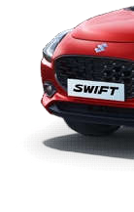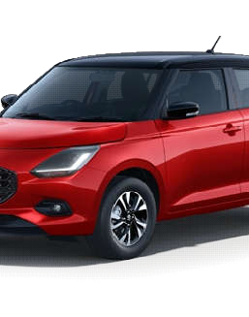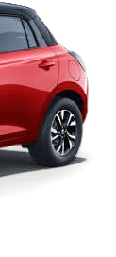

3.10.2 WAGON R
The Maruti Suzuki Wagon R is a popular hatchback that has left an indelible mark on Indian roads.The heart of the Wagon R beats with the revolutionary Z-Series 1.2L engine, combining innovation, technology, and sustainability.The Idle Start Stop (ISS) feature enhances fuel efficiency by automatically turning off the engine when the car is stationary and restarting it when you’re ready to move.Safety is a priority in the Wagon R. It comes equipped with dual front airbags, providing protection for both the driver and front passenger.The Wagon R’s robust design language features a wide stance, making it sturdy and strikingly attractive.The Auto Gear Shift in the Wagon R lets you experience an advanced blend of comfort and technology.

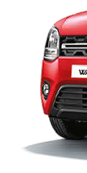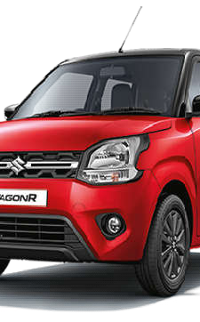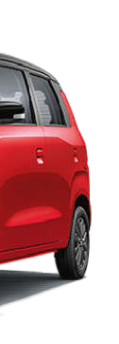

3.10.3 BREZZA
The Brezza isn’t for those who shy away from attention—it’s for the ones who thrive on it.Its masculine upright stance with Geometric Fenders demands notice.Featuring Dual LED Headlamps with LED DRLs and LED Tail Lamps, the Brezza exudes energy and style.Make a statement with Dual Tone Colours, a hard-to-miss Shark Finn Antenna, and bold Geometric Alloy Wheels that command the roads.The Brezza boasts an array of features like Electric Sunroof, Head-Up Display,Suzuki Connect, SmartPlay Pro+ A 22.86cm (9-inch) infotainment system with wireless Apple CarPlay® and Android Auto,Wireless Charging Dock: Keep your devices juiced up on the go.360 View Camera,The Brezza is powered by a 1.5L Petrol Engine that offers best-in-class performance and fuel efficiency.It’s available in both manual and automatic transmissions.Safety features include 6 airbags for peace of mind.
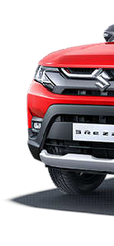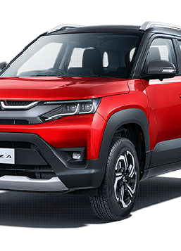

3.10.4 CELERIO
The Maruti Suzuki Celerio is a versatile hatchback that combines practicality, efficiency, and style. Here are the key details about this popular car:
The Celerio features a 3D Organic Sculpted Design that is refreshing to the senses.Notable exterior elements includes, Radiant Front Grille with Sharp Chrome Accents,Droplet-Styled Taillamps, 15-inch Black Alloy Wheels for a sporty look, Energetic and Spacious Cabin. The Celerio comes equipped with features such asAuto Gear Shift (AGS) for effortless driving, Engine Push Start-Stop Button for convenience, Steering Mounted Controls for easy access.The Celerio is available in LXI, VXI, and ZXI variants.It is powered by the Next Gen K10C Petrol engine. It offers a comfortable seating capacity for 5 passengers.

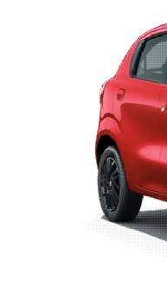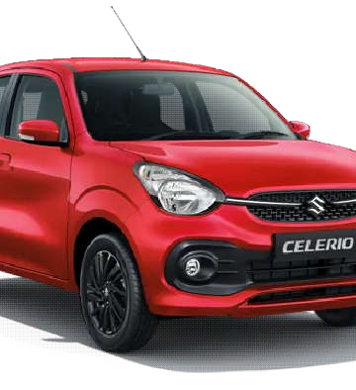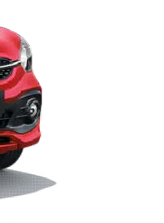

3.10.5 ALTO K 10
The Alto K10 is a compact hatchback that combines practicality, efficiency, and affordability. Here are the key features of this popular car includes The Alto K10 is powered by a 1.0L K-Series Petrol Engine, delivering a zippy and efficient performance.It’s available in both manual and automatic transmissions.The Alto K10’s compact dimensions make it ideal for city driving and parking.Despite its compact size, the Alto K10 offers a surprisingly spacious cabin.Features include power windows, steering-mounted controls, and a 7-inch infotainment system.Passenger safety is a priority, with dual front airbags, ABS with EBD, and rear parking sensors.

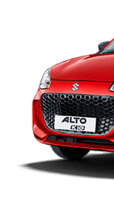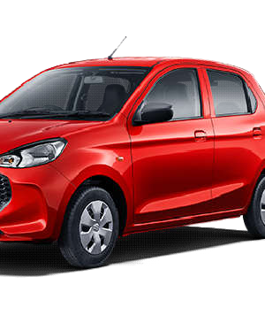

3.10.6 S-PRESSO
The Maruti Suzuki S-Presso is a compact and spirited miniSUV that adds a dash of excitement to your daily drives. Its key features includethe S-Presso stands out with its bold and upright stance.Features like the high bonnet, SUV-inspired front grille, and tall pillars give it a rugged appeal.Under the hood, you’ll find a 1.0L K-Series Petrol Engine that delivers a lively performance.Whether you’re navigating city streets or hitting the highway, the S-Presso keeps up with ease.The SmartPlay Dock infotainment system keeps you connected on the go.Safety features include dual airbags, ABS, and rear parking sensors.The S-Presso prioritizes your well-being.

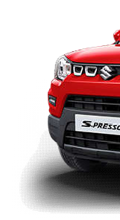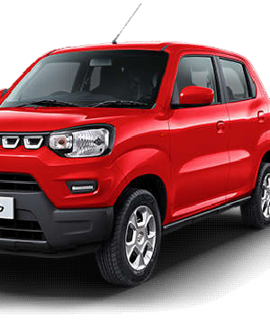

3.10.7 ERTIGA
The Maruti Suzuki Ertiga is a versatile 7-seater MUV (Multi-Utility Vehicle) that combines practicality, comfort, and advanced features. Let’s explore its key highlights:
The Ertiga flaunts a bold personality with its sculpted design.It measures 4395 mm in length, 1735 mm in width, and stands 1690 mm tall (unladen).The wheelbase of 2740 mm ensures ample cabin space.The Ertiga is equipped with state-of-the-art technology:17.78 cm Smartplay Pro infotainment system with Arkymys Sound.6-Speed AT with Paddle Shifters for smooth driving.Wireless Android Auto & Apple Car Play for seamless connectivity.TFT Multi-Information Colour Display with turn-by-turn navigation.Cruise Control for added convenience.Safety is paramount, with quad airbags ensuring protection for all occupants.The Ertiga also features ABS, ESP, and rear parking sensors.

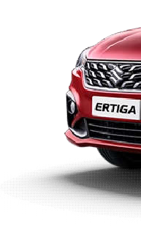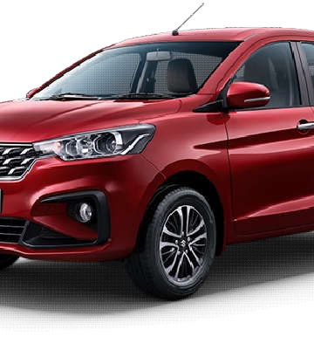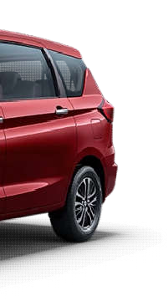

3.10.8 VICTORIS
Maruti Suzuki Victoris is a highly popular,5-seater mid-size SUV sold exclusively through Maruti’s Arena dealerships .That was introduced as a premium family-focused vehicle. It is positioned as a rival to SUVs like the Hyundai Creta and Kia Seltos. According to automotive reports, it is available with petrol, CNG, and hybrid powertrain options.Let’s explore its key highlights:
It have Immersive infinity speakers with Dolby Atmos spatial sound, a smart powered Tailgate with Gesture control,Advanced level 2 ADAS,64-colour ambient lighting, and the choice of strong hybrid and underbody CNG for efficiency.Add to that a panoramic sunroof, ventilated seats, wireless charging, a fully digital 26.03 cm TFT cluster,all grip select AWD,6 airbags with 360°HD view camera, and Victoris truly has its all technology, safety, comfort, and performance in one bold SUV

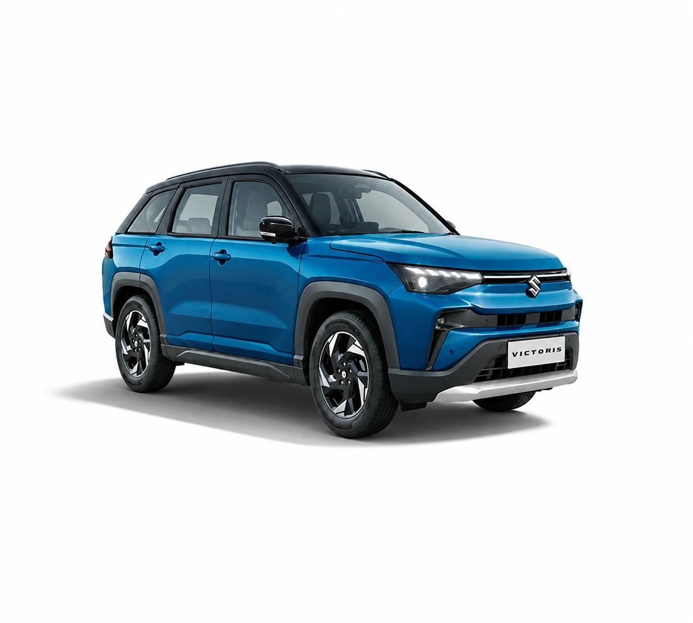

CHAPTER 4

ANALYSIS AND INTERPRETATION

4.1 SWOT ANALYSIS
SWOT analysis is framework for identifying and analysing an organization's strengths, weaknesses, opportunities and threats. These words make up the SWOT acronym.
The primary goal of SWOT analysis is to increase awareness of the factors that go into making a business decision or establishing a business strategy. To do this, SWOT analyses the internal and external environment and the factors that can impact the viability of a decision.
A SWOT analysis examines both internal and external factors that is, what's going on inside and outside your organization. So some of these factors will be within the control and some will not. In either case, the wisest action that a company can take in response will become clearer once it discovered, recorded and analysed as many factors as it can.
Strength, weakness, opportunities and threats are the elements or key factors that influence the survival and development of any organization. The followings are the SWOT analysis of Popular Maruti Arena, Pallikkunnu.

STRENGTHS
Strengths describe what an organization excels at and what separates it from the competition. It may be a strong brand, loyal customer base, motivation of employees,efficient management, unique technology, and so on. Some of the strengths of Popular Maruti Arena includes:
- Dedicated and efficient workforce:
The dealership has access to experienced staff members who understand the selling and servicing Maruti Suzuki vehicles.

- Customer-centric approach:
Popular Maruti Vehicles prioritizes a customer-centric approach, focusing on understanding and fulfilling the needs and preferences of its customers. This approach enhances customer satisfaction, fosters loyalty, and generates positive word-of-mouth, ultimately driving repeat business and referrals.
- Long standing presence:
Over the years, it has built strong relationships with customers, suppliers, and other stakeholders, benefiting from brand recognition, reputation, and local market knowledge. This longevity enhances trust and credibility, contributing to the dealership's competitive advantage and sustainability.
- Brand Reputation:
Popular Maruti Vehicles benefits from the reputation of both the Maruti Suzuki brand and the Kuttukkaran group, which can enhance trust and credibility among customers.
- Employee Training and Development:
The dealership prioritizes ongoing training and development for its staff members, ensuring that they stay updated on industry trends, product innovations, and customer service best practices.

WEAKNESSES
Weaknesses stop an organization from performing at its optimum level. They are areas where the business needs to improve to remain competitive: a weak brand, higherthan-average turnover, high levels of debt, an inadequate supply chain, or lack of capital. Some weakness of this company includes:
- Limited Digital Presence:
Inadequate online presence or outdated digital marketing strategies can result in missed opportunities to reach and engage with potential customers, especially in today's digital age.
- Dependency on Traditional Sales Channels:
Reliance solely on traditional sales channels like walk-in customers or referrals may limit the dealership's reach and hinder its ability to adapt to changing consumer behaviours.
- Limited Community Engagement:
A lack of involvement in local events or initiatives can reduce brand visibility and community support. By not participating in activities like sponsoring sports teams or charity events, the dealership misses opportunities to build relationships with potential customers.

OPPORTUNITIES
Opportunities are openings or chances for something positive to happen.They usually arise from situations outside your organization, and require an eye to what might happen in the future.
- Digital Marketing:
Leveraging digital marketing channels can help the dealership reach a wider audience and engage with potential customers, especially in the digital age where online presence is crucial.
- Focus on Electric Vehicles (EVs):

By focusing on electric vehicles (EVs), Popular Vehicles and Services Limited (PVSL) can diversify its product portfolio to meet the evolving demands of consumers and the changing automotive landscape. The company can collaborate with leading electric vehicle manufacturers or invest in its own EV manufacturing capabilities to ensure a wide selection of EV models, catering to various customer preferences and market segments.
- The demand for premium cars:
In addition to focusing on EVs, PVSL can seize the opportunity presented by the demand for premium cars. Premium cars appeal to consumers seeking luxury, performance, advanced features, and status symbols. PVSL can partner with prestigious automotive brands or introduce its own line of premium vehicles to cater to this affluent segment of the market. By offering high-end vehicles with cutting-edge technology, superior craftsmanship, and personalized services, PVSL can attract discerning customers and capture a larger share of the premium automotive market.

THREATS
A "Threat" refers to any external factor or condition in the business environment that could potentially hinder or negatively impact the success, growth, or sustainability of a business or its objectives. Threats are typically elements or developments outside the control of the organization but could still pose risks or challenges to its operations, performance, or competitive position.
- High Competition:
The company operates in a highly competitive automotive market, facing competition from both domestic and international manufacturers, dealerships, and online platforms. Rivals may offer similar products, pricing strategies, and customer incentives, posing a threat to PVSL's market share, profitability, and customer retention.
- Regulatory Changes:
Changes in government regulations related to emissions, safety standards, or taxation can impact the automotive industry's operating environment and increase compliance costs for the dealership.
- Changing Consumer Preferences:
Shifts in consumer preferences towards alternative mobility solutions, such as ridesharing or electric vehicles, could disrupt traditional car ownership patterns and reduce demand for new vehicles.
- Economic Uncertainty:
Economic downturns, inflation, or changes in consumer spending habits can negatively impact the dealership's sales and profitability.

CHAPTER 5
FINDINGS, RECOMMENDATIONS AND CONCLUSION

AN ORGANISATIONAL STUDY ON MARUTI SUZUKI ARENA (POPULAR VEHICLES& SERVICES) PALLIKKUNNU, KANNUR

5.1 FINDINGS
- The company have a strong brand reputation.
- Popular has built a reputation for trust, transparency, and quality • Have a Strategically positioned dealership locations.
- Company is conducting Continuous training and development programmes to keep employees updated.
- Experienced and knowledgeable staff.
- Have a strong and effective leadership and management.

5.2 RECOMMENDATIONS
- Enhance Online Presence.
- Focuson Providing fastserviceswithoutdelay.
- Implement environmentally sustainable practices.
- The company can engage with the local community by participating in events and sponsoring initiatives
- The company should reduce paper usage.
- Should Focus on reducing energy wastage.

AN ORGANISATIONAL STUDY ON MARUTI SUZUKI ARENA (POPULAR VEHICLES& SERVICES) PALLIKKUNNU, KANNUR

CONCLUSION
The organization study carried out at Popular Maruti Arena, Pallikkunnu, Kannur was successful in achieving the specific objectives. It helped to familiarize with the organization structure and its functioning. The study also helped to know different departments in the organization and their functions and activities.
The study helped to understand how the key business processes are carried out in an organization regards to dealer perspective.
The dealership operated by the Kuttukkaran Group stands as a shining example of excellence in the automobile industry. Through a steadfast commitment to customer satisfaction, innovative practices, and a dedicated team, the dealership has not only strengthenedits position as a market leader but has also earned the trust and loyalty of its customers.
The study helped in improving practical knowledge and it was beneficial as it helped to gain awareness about the organization culture.

58

INSTIT
UTE OF TECHNOLOGY, MAYYIL, MBA 2023
-
25

BIBLIOGRAPHY

BIBLIOGRAPHY

BOOKS
- Kothari, C.R., "Research Methodology", New Age International Publishers,
New Delhi, Second Edition, 2006

- Aswathappa, K., "Human Resource and Personnel Management", Tata MC Graw Hills, New Delhi, Second Edition, 2006

URL’s
- https://www.history.com/topics/inventions/automobiles
- https://www.popularmaruti.com
- https://www.goodreturns.in/company/popular-vehicles-and-services/history.html
- https://www.statista.com/statistics/1090709/india-car-sales-volume-by-oem/
- https://ackodrive.com/car-guide/car-segments-in-india/

